After the bomb: Mountbatten's tragedy and a twin brother's act of devotion

FROM A CLEAR BLUE SKY: SURVIVING THE MOUNTBATTEN BOMB BY TIMOTHY KNATCHBULL (Hutchinson)
By Sam Leith
Last updated at 4:15 PM on 18th September 2009
On Monday August 27, 1979, the IRA used a remote-control device to detonate a bomb aboard a boat near Mullaghmore in County Sligo. They killed an old man, an old woman, two teenage boys and a dog, did these brave freedom-fighters.
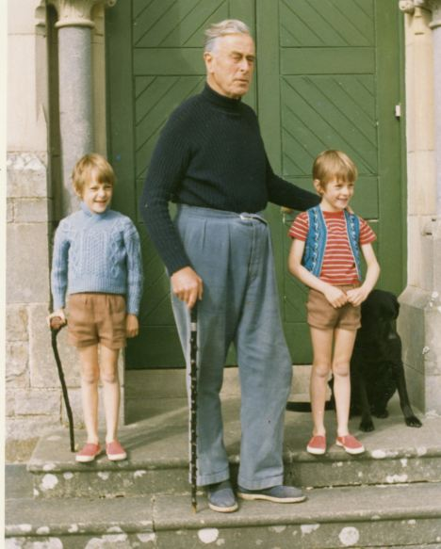
Lord Mountbatten with Tim Knatchbull and twin Nicky in 1971.
'I don't glorify death,' one supporter later reflected with a charmless mixture of machismo and humbug, 'but I had personal pride in what happened because it was a military operation and they took him out.'
'Him' was Lord Mountbatten, 79, who every year spent his August holidays with his family at Classiebawn Castle. Never mind that in Burma and India Mountbatten had sought to make peace with nationalists and helped dismantle the British imperialism he represented; never mind that he was on holiday not in the 'occupied' north but in the Republic; never mind that he was a private citizen some years into retirement.
He was an English toff, and a symbol of imperialism, so that was that. To those watching the boat from their binoculars on the clifftop the presence of multiple civilians, including teenage children, was no impediment to setting off a bomb.
Those deaths would be an 'unfortunate' or 'regrettable' by-product of what their leaders admitted was no more than a bloody publicity stunt: 'to bring to the attention of the English people the continuing occupation of our country'.
Timothy Knatchbull, Mountbatten's 14-year-old grandson, was with him that morning aboard Shadow V - along with his identical twin brother Nicholas, both his parents, his paternal grandmother Lady Brabourne, and their friend, 15-year-old Paul Maxwell, who was helping on the boat.
'A few minutes later Paul, Nick and my grandfather lay dead in the water. A bomb had detonated under their feet. The wooden boat had disintegrated into matchwood which now littered the surface, and a few big chunks which went straight to the seabed. My grandmother was pulled into a nearby boat but died the next morning in the Intensive Care Unit of Sligo Hospital. She was 83. I lay in the bed beside hers with wounds from head to toe. Surgical tubes led into my body.
'Opposite, my mother was connected to a machine that breathed for her; she was not expected to live. Her face was unrecognisable, held together by 117 stitches, 20 in each eye. In a nearby ward lay my father, his legs twisted and broken and multiple wounds all over his body. Between the three survivors we had three functioning eyes and no working eardrums.'
From A Clear Blue Sky is the minute-by-minute story of what happened on that day, and what happened afterwards. It is a proper four-hanky bawler, and the exactitude of the story is what makes it so moving.
Knatchbull's tender attention to the actual comes to feel like an act of devotion: a determination to rescue the texture and sound and incidental detail of the last day of his brother's life from history.
Everything is preserved. You learn about the fragments of Monty Python sketches that Timothy gabbled to his doctors while under sedation; about the back-issue of the New Statesman Knatchbull's mother was reading before she was blown up; what television programme a relative was watching when he heard the news.
He reports how the body of Twiga, Knatchbull's mother's miniature dachshund, was placed at the Cliffoney Garda Station beside detritus from the explosion: 'the broken tip of a fishing rod; parts of a green plastic cushion; scraps of foam rubber from a seat; one blue sneaker with the side blown away'.
And when, in the book's closing chapters, Knatchbull visits the now-retired state pathologist and is shown the photographs of his brother's body, what he zeroes in on is the woollen V-neck jumper knitted by their Nanny: 'I hadn't thought of that jumper since I last saw Nicky.' In addition to its memorialising power, the accretion of human detail in this book has another effect. It serves to show up the pitiful failure of imagination in those who committed the crime - the thinness of their abstract cause against the density of human hurt they inflicted for it.
'I was 11 years old,' India Hicks recalled of going, along with her mother, to visit her cousin in hospital in Ireland, 'and I had never heard of a political assassination before.' The only two men ever charged with the crime - Thomas McMahon was convicted; his confederate Francis McGirl acquitted - come across as vicious chumps.
McGirl blurted, notoriously: 'I put no bomb on the boat' to the police before anyone had mentioned a bomb or a boat. McMahon was attempting an armed prison-break even as he whiningly sued to be compensated for a broken arm sustained in custody.
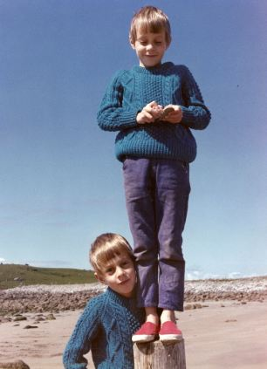
This is less the story of the bombers and the political repercussions of the murder - though these are intelligently and dispassionately touched on - than it is the story of a personal coming-to-terms. The central loss - for this narrative - is not Lord Mountbatten of Burma, but Nicky Knatchbull.
The loss of a twin is an almost unimaginable grief. Nick and Tim could be told apart only by the presence of a small mole under Tim's chin, and they spent nearly every moment of 14 years together. To lose Nicky was not just to lose a sibling, but a part of himself.
As an adult, Knatchbull was stalked by the fear of abandonment, and prone
to flashbacks. The smell of diesel at a petrol station would recall him to the diesel-slicked water after the bomb; and the click of an electrical circuit closing would cause the sound of the bomb to echo in his head.
He quotes at one point Joan Didion's distinction between grief and mourning - the former being a passive process, something you undergo; the latter being the active and deliberate way in which you take control of your grief, and let it go.
For years, he grieved. This is the account of how he learned, belatedly, to mourn. But (despite the lousy title) there's not too much cant about 'healing'. He tells his own story, and leaves it at that. It may not work for you but this worked for me, he says, and you believe him.
In the first part of the book, then, he tells you about his family. They are proper toffs, too. A postcard from Mountbatten is recalled where, comically, he describes staying in the Kremlin in 1908 'when my Uncle Nicky was Tsar'. Knatchbull spent part of his time recuperating from the bomb at Balmoral, and the Queen appears, off-duty and in a tenderly maternal light.
Under those gewgaws it's a story of any family holding together after a disaster. It is affecting and intimate: the way his parents, in intensive care, dictated love-letters, and when reunited in a ward had their beds pushed together: 'At night they held hands. It was the first time I saw my father cry.'
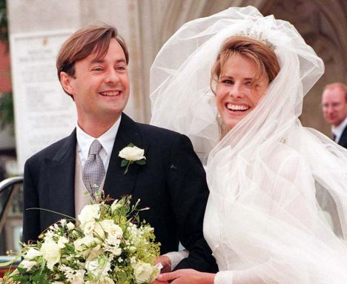
Timothy Knatchbull at his wedding to Isabella Norman outside Winchester Cathedral, July 11, 1998.
The story of the bomb and his family's physical recovery is one part. But in the early years of the new millennium, Knatchbull - now married and with children of his own - started to return to Ireland.
He went back, researching his own story, to talk to the people who witnessed the explosion; the policemen who investigated it; the father of Paul Maxwell, also killed on the boat; the men who saved his life and those who fished the bodies of his brother and grandparents out of the water.
Some answers - by the nature of his investigation - are elusive. There is an anxious and painful circling round the question of to what extent their Sligo neighbours allowed, rejoiced in, or even helped with, the murders. Knatchbull will never be the man, he realises, best placed to get to the bottom of that.
He provides a convincing account, though, of the extent to which he has been able to accept, forgive and move on. His narrative power is such that the reader can't always share his equanimity. It is a book that is as saddening as it is sad - but much more angering than it is angry.
A nice detail, incidentally, is where Thomas McMahon learned his craft: 'By the late Seventies, Thomas McMahon was among the IRA's most capable bomb-makers.
A carpenter by trade, he married Rose McArdle on July 6, 1975, in Carrickmacross, County Monaghan. The married couple moved into a bungalow he built in nearby Lisanisk.
'Soon afterwards he underwent training in Libya at the arrangement of the country's dictator, Colonel Gaddafi.'

