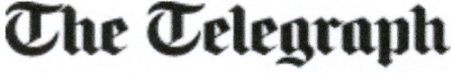

Grandson of Lord Mountbatten 'forgives' IRA terrorists who killed his grandfather

The grandson of Lord Mountbatten – the late cousin of the Queen – has forgiven the IRA terrorists who killed his grandfather, grandmother and twin brother.
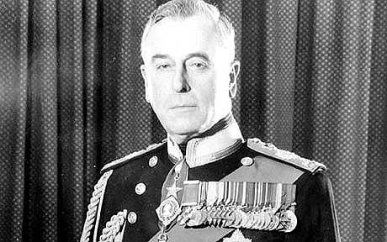
Lord Mountbatten was the last viceroy of the British Indian Empire Photo: PA

By Jon Swaine 11:49AM BST 27 Aug 2009
Timothy Knatchbull, who survived the bombing of the family’s boat in County Sligo, Ireland, said that it had taken him 25 years to get over the incident and feel “forgiveness” for those responsible.
Lord Mountbatten, a decorated Second World War veteran and the last Viceroy of the British Indian Empire, was killed in the blast. He was 79.
Mr Knatchbull, 44, has written a book about his life since the attack. It took place when he was 14 and also killed his twin, Nicholas, his grandmother Lady Brabourne and Paul Maxwell, a 15-year-old boy who worked on the boat.
It describes visits he made to Ireland in 2003 and 2004, his first since the bombing, during which he gained an understanding of what happened and of the motives of the bombers.
“I needed to move on and get into a state of forgiveness that had eluded me,” Mr Knatchbull said. “When I tried to look into the events I found that precious little was known about who did what and how and when.
“By digging deep and finding out for myself first hand what had happened, who had done it and indeed why, I was able to get to a whole new level of forgiveness and indeed healing.”
He said that the visits and discussions with Irish people had helped him get over the loss of Nicholas, from whom he could be told apart only by a mole on his chin.
“It was very difficult for me to accept that Nicholas had gone, at some deep psychological level,” Mr Knatchbull told the BBC.
“He was still too present in my mind and in my heart. That was partly because I never saw him, I never had a goodbye, I never saw his dead body, and I was – like my parents – unable to travel from hospital to be at his funeral. So by going back to Ireland, I was able to piece together what I needed to have that experience.
Mr Knatchbull also recounted the immediate aftermath of the bombing, which took place near the fishing village of Mullaghmore.
“My memories of that are terribly snatched – a sensation of the explosion, and then the next thing I knew I remember being at the bottom of a boat, and I could feel a very hard floor that I was on, a wooden floor and I could hear vibration.
“And I could hear some very frightened, very emotionally charged kindly voices. Irish accents. I knew that something was dreadfully wrong, and I knew there was something dreadfully wrong with me, but quite what I couldn’t tell.”
Mr Knatchbull had suffered perforated eardrums and shrapnel wounds, and sustained damage to his right eye, which was already week and in which he is now effectively blind.
He said that the rest of his family had been able to “get on with their lives” quickly after the bombing and had a “remarkable lack of bitterness”.
The IRA quickly admitted carrying out the bombing. They said it was designed to “bring to the attention of the English people the continuing occupation of our country."
Thomas McMahon, 31, was convicted of the murders of those who died in the attack. He was released in 1998 under the Good Friday Agreement.
Earlier this month it emerged that McMahon lives with his wife Rose in a hillside bungalow in Lisanisk, close to the market town of Carrickmacross in Co Monaghan. He is believed to work as a carpenter.

