Victims include survivors
10 Feb 2010

Margaret von Klemperer

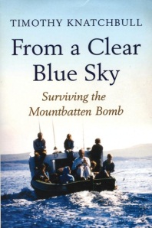
BOOK REVIEW
From a Clear Blue Sky: Surviving the Mountbatten Bomb
Timothy Knatchbull
Hutchinson
IN 1979, when the Irish Republican Army (IRA) detonated a bomb in the ancient fishing boat that Lord Mountbatten had just taken out to check lobster pots near his holiday home in Ireland, the victims included not only the four dead — Mountbatten, his daughter’s mother-in-law, one of his 14-year-old twin grandsons and the local teenager who had been employed for the summer to work on the boat — but also the survivors and their families. It was an event that has reached long fingers down the 30 years that have passed.
Timothy Knatchbull is the surviving twin, and for him the ramifications of that sunny Irish morning have been enormous.
Timothy and Nicholas were identical twins, and, until Nicholas’s death, had never been parted for more than a day or two in their entire lives. For Timothy, his brother’s death was the amputation of half of himself and, although on the surface he coped heroically and recovered from his own serious injuries, the scars left have been deep.
The Mountbatten family were and are enormously privileged people, and to the IRA and many Irish people who were never actively involved in their campaigns, they were a legitimate target for terror.
For terror’s victims, as for the victims of any crime, it is a big stretch to be able to consider both sides of questions of this kind. And this is one of the things that makes Timothy Knatchbull’s book a worthwhile one.
As he explores the bombing, and his very personal reaction to it, particularly to the death of his twin, he also considers the situation in Ireland at the time in a measured way. He has never met the only man convicted of the bombing (although, as becomes clear, it was an operation that involved several people) but he has explored the circumstances in detail.
From a Clear Blue Sky is a very personal book. Knatchbull draws a portrait of a close family ripped apart and the trauma that has caused. He also looks into the bond between twins and what happens if one becomes a “lone twin”.
But his book is not maudlin and is a moving portrait of a man who in coming to terms with a personal tragedy manages to consider a wider situation.

