News

Service marks Mountbatten murder
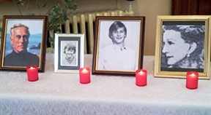
One of the darkest days of the Troubles has been remembered - the IRA murder of the Queen's cousin Lord Mountbatten with a bomb on his fishing boat off the west coast of Ireland, 30 years ago.
Thursday, 27 August 2009
On August 27 1979, the IRA detonated a bomb on Lord Mountbatten's boat Shadow V which had just set off from the fishing village of Mullaghmore in Co Sligo.
It was where the 79-year-old Earl traditionally spent a family summer holiday at their Classiebawn Castle, previously untroubled despite the ongoing violence across the border.
One of Mountbatten's twin grandsons, Nicholas, 14, as well as local teenager Paul Maxwell, 15, also died in the blast. The Dowager Lady Brabourne, 83, died later from her injuries.
Narrow Water
While the news was still reverberating around the world, the IRA detonated two 800lb bombs beside Narrow Water Castle at Warrenpoint, Co Down.
The first explosion killed 16 members of the Parachute Regiment, the second two members of the Queen's Own Highlanders who had been sent to the scene.
A civilian, Londoner Michael Hudson, who was one of the Queen's royal coachmen, was shot dead while bird watching on a nearby island when soldiers opened fire across Carlingford Lough into the Irish Republic where they believed the bombers had detonated the devices.
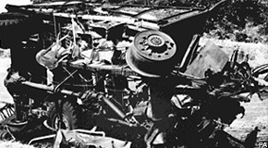
It was the army's largest single loss of life in more than 35 years in Northern Ireland, indeed it was the largest single loss of life in any single event of the Northern Ireland violence until the dissident Real IRA detonated the Omagh bomb in August 1998 killing 29 people including a mother pregnant with twins.
Both events were remembered at memorial services at Mullaghmore and Narrow Water.
An ecumenical service at the Star of the Sea Church in Mullaghmore marked the 30th anniversary of Mountbatten's death.
It was attended by friends and staff of the Mountbattens, the Maxwell family as well as local residents of the village.
On the other side of the country, and border, another memorial service was held at Narrow Water at 3.15pm, the precise moment the first bomb exploded. It was followed by a wreath laying ceremony.
The Parachute Regiment did not return to the scene but holding its own private memorial behind the walls of a military base in Northern Ireland and their English headquarters.
'Remember'
William Frazer, director of anti-republican pressure group Fair - Families Acting for Innocent Relatives - organised the Narrow Water memorial.
He said it was important to remember all those killed or maimed on what he said was one of the most significant days of the Troubles.
"It is important that we pause and remember the carnage inflicted by the IRA at Narrow Water 30 years ago".
"We can reassure the families of all who died on that fateful day in August 1979 that they and their loved ones are not forgotten."
He added: "The victims of IRA terrorism are determined to bring those responsible for what can only be described as a barbaric and inhumane act to justice."
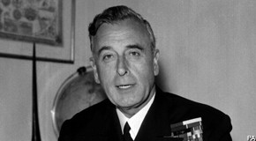
The IRA murdered Lord Mountbatten, the Prince of Wales' favourite uncle, because he was a member of the Royal Family.
Ironically, secret Irish government files made public in Dublin in 2007 claimed Lord Mountbatten privately wished for a united Ireland.
They said he told the Irish Ambassador to London in 1972 that he would be happy to help with efforts to secure a lasting peace on the island and reunification.

