Why I've finally forgiven the IRA: Thirty years on, Mountbatten's grandson speaks
By Sam Greenhill
Last updated at 9:02 AM on 28th August 2009

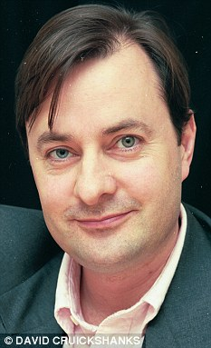
Timothy Knatchbull says he battled personal demons to finally forgive his grandfather's killers
Thirty years after the IRA murdered Earl Mountbatten, his grandson Timothy Knatchbull yesterday told of finally finding peace and forgiveness.
Mr Knatchbull was just 14 when the Provisionals blew up his family's boat. He narrowly survived but his twin brother Nicholas was among the four killed.
The 1979 atrocity off Ireland's west coast shocked the nation and in particular Prince Charles, who regarded Earl Mountbatten as his mentor.
Yesterday Mr Knatchbull, 44, revealed how he battled his personal demons by revisiting the scene of the bombing and speaking to his rescuers.
Telling his story publicly for the first time, he said: 'I did it very quietly and very privately in 2003 and 2004 and I found that by digging deep and finding out for myself first hand who did it and how, and indeed why, I was able to get to a whole new level of forgiveness and healing.'
On the August bank holiday weekend in 1979, Earl Mountbatten, an uncle of Prince Philip, took members of his family out for a trip in his 27ft fishing vessel, the Shadow V, off Mullaghmore in County Sligo.
A remote controlled bomb had been attached to it overnight.
Recalling the day that turned to tragedy, Mr Knatchbull told BBC Radio 4's Today: 'It was a tremendously happy relaxed family holiday in the west of Ireland and we went out on a beautiful flat calm sea.
'We had only gone about a quarter of a mile when there was a really dreadful explosion and my memories of that are snatched - a sensation of the explosion and then the next thing I knew I remember being in the bottom of a boat .'
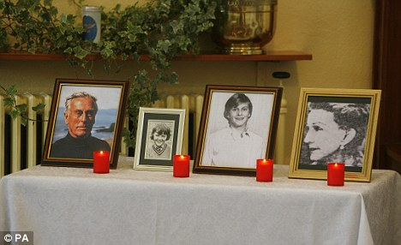
(From left to right) Portraits of Lord Mountbatten, Paul Maxwell, the Hon Nicholas Knatchbull and Lady Doreen Bradbourne sit on the altar during an ecumenical service to mark the 30th anniversary of the death of Lord Mountbatten
Mr Knatchbull was pulled from the sea with shrapnel wounds.
The bomb had killed his 79-yearold grandfather, his maternal grandmother Lady Brabourne, boathand Paul Maxwell and his brother.
Mr Knatchbull said it took him weeks to recover physically but years emotionally. 'I was lucky, I took a cue from others in my family who were able to get on with their lives and have a remarkable lack of bitterness and ability to heal,' he said.
'But I never had a chance to say goodbye to my dead twin Nicholas and this prevented me from really making a full mental and emotional recovery.'
By going back to Ireland and talking to many people, Mr Knatchbull found that his symptoms- including 'hearing' the bomb every day - evaporated.
Now married with five children and running a media business in London, he has written a book, From A Clear Blue Sky, about his psychological journey to peace.
It was originally due to be published yesterday, the 30th anniversary of the atrocity, but it was postponed for a week as some relatives were upset it was to appear on a date they would rather forget.

