Out now in paperback
By Harry Ritchie, Last updated at 5:13 PM on 13th August 2010

FROM A CLEAR BLUE SKY by TIMOTHY KNATCHBULL
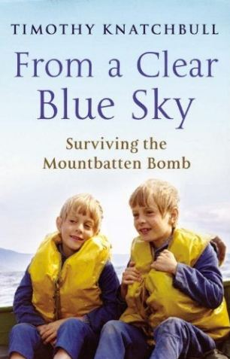
It was Bank holiday Monday in August 1979. Timothy Knatchbull was 14 and on holiday with his family in Ireland. That morning, he was on a boat trip just off the coast of Sligo. Just before midday, the bomb planted by the IRA on that boat exploded, killing four of the people on board, including the author's identical twin brother, Nicholas, and their grandfather, Lord Mountbatten.
Thirty years later, Timothy confronts that cataclysmic event in this amazingly clear-headed and mature book. It is part family memoir, part love-letter to the twin he lost, and also the story of his own quest to understand exactly what happened that day and why, and to find forgiveness for the terrorists who blew his life apart.
Intelligent, honest, tender, and so moving that it should come with a warning to read this in private because you're going to be in a tear-stained mess.

