Jenny’s pick, posted online December 23, 2011

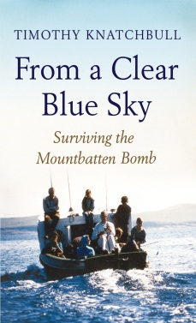

On a clear blue sky day in August 1979, 14 year old Timothy Knatchbull went fishing with his grandfather and family, they were on holiday in Ireland, and had no idea that the IRA had planted explosives just under the timber deck they were standing on.

Some of you will remember the bombing of Lord Mountbatten’s boat. Here Timothy gives a personal and moving account of the events that took place that day, which made headlines around the world. He also relays the recollections by many others. He lets you in on the enormous suffering and loss he incurred that day, he tells of the heart breaking loss of his identical twin brother Nicholas, they were inseparable, and I found myself asking, how is he ever going to survive without Nick by his side?
He also conveys the wonderful support he and his family received and gave to each other.
This book did have me in tears at times, but it’s not a book about humans inflicting misery on each other, it’s about how we learn to overcome tragedy and move on to cherish the wonder of being alive, and the relationships that enrich our lives.

Parramata Library has this book on Playaway talking book and it is also narrated by Timothy himself. Well worth a listen.

